# **Practical Exercise: Managing Alerts with Real-Time Analytics**

Training Objective

Learn how to generate alerts for a scenario when the tier limit is hit frequently.

Business Scenario

PizzaShack Limited needs to generate alerts if users exceed their tier limits frequently.

High-Level Steps

* Generate and view alerts
* Configure alert generation related parameters

Create a Traffic Alert for API

**Note:** API Manager and API Manager Cloud Analytics must be configured. (This has been covered in the previous exercise.)

1. Enable alerts in the <APIM_ANALYTICS_WORKER_HOME>/conf/worker/deployment.yaml and restart the worker node.

analytics.solutions:

APIM-alerts.enabled: **true**

1. Create a subscriber level throttling tier with a small number of requests per minute. E.g., 2 requests per minute. ( Refer [documentation](https://apim.docs.wso2.com/en/4.0.0/learn/rate-limiting/adding-new-throttling-policies/#adding-a-new-subscription-level-throttling-tier) )
2. Log in to the API Publisher.
3. Click on the PizzaShack API and click **Subscriptions** tab.
4. Apply the new business plan and click **Save** and then Publish the API if not already.
5. Login to API Devportal and select the PizzaShack API.
6. Subscribe to an application using the new tier.
7. Invoke the API rapidly till it throttles out. After 2 requests, you should get a throttled-out message. Keep on sending requests (more than 10) to generate an alert (by default an alert is generated when there are 10 alerts more than the limit).
8. Log into the analytics-dashboards app ( <https://localhost:9643/analytics-dashboard/> ) and go to Alerts page to see the alert being generated.

Configure Alert Generation Related Parameters

1. Login to the Business Rules application  
   (e.g., <https://localhost:9643/business-rules>).
2. In the **Business Rules Manager,** the following kind of configuration page for all the alert types is displayed.  
   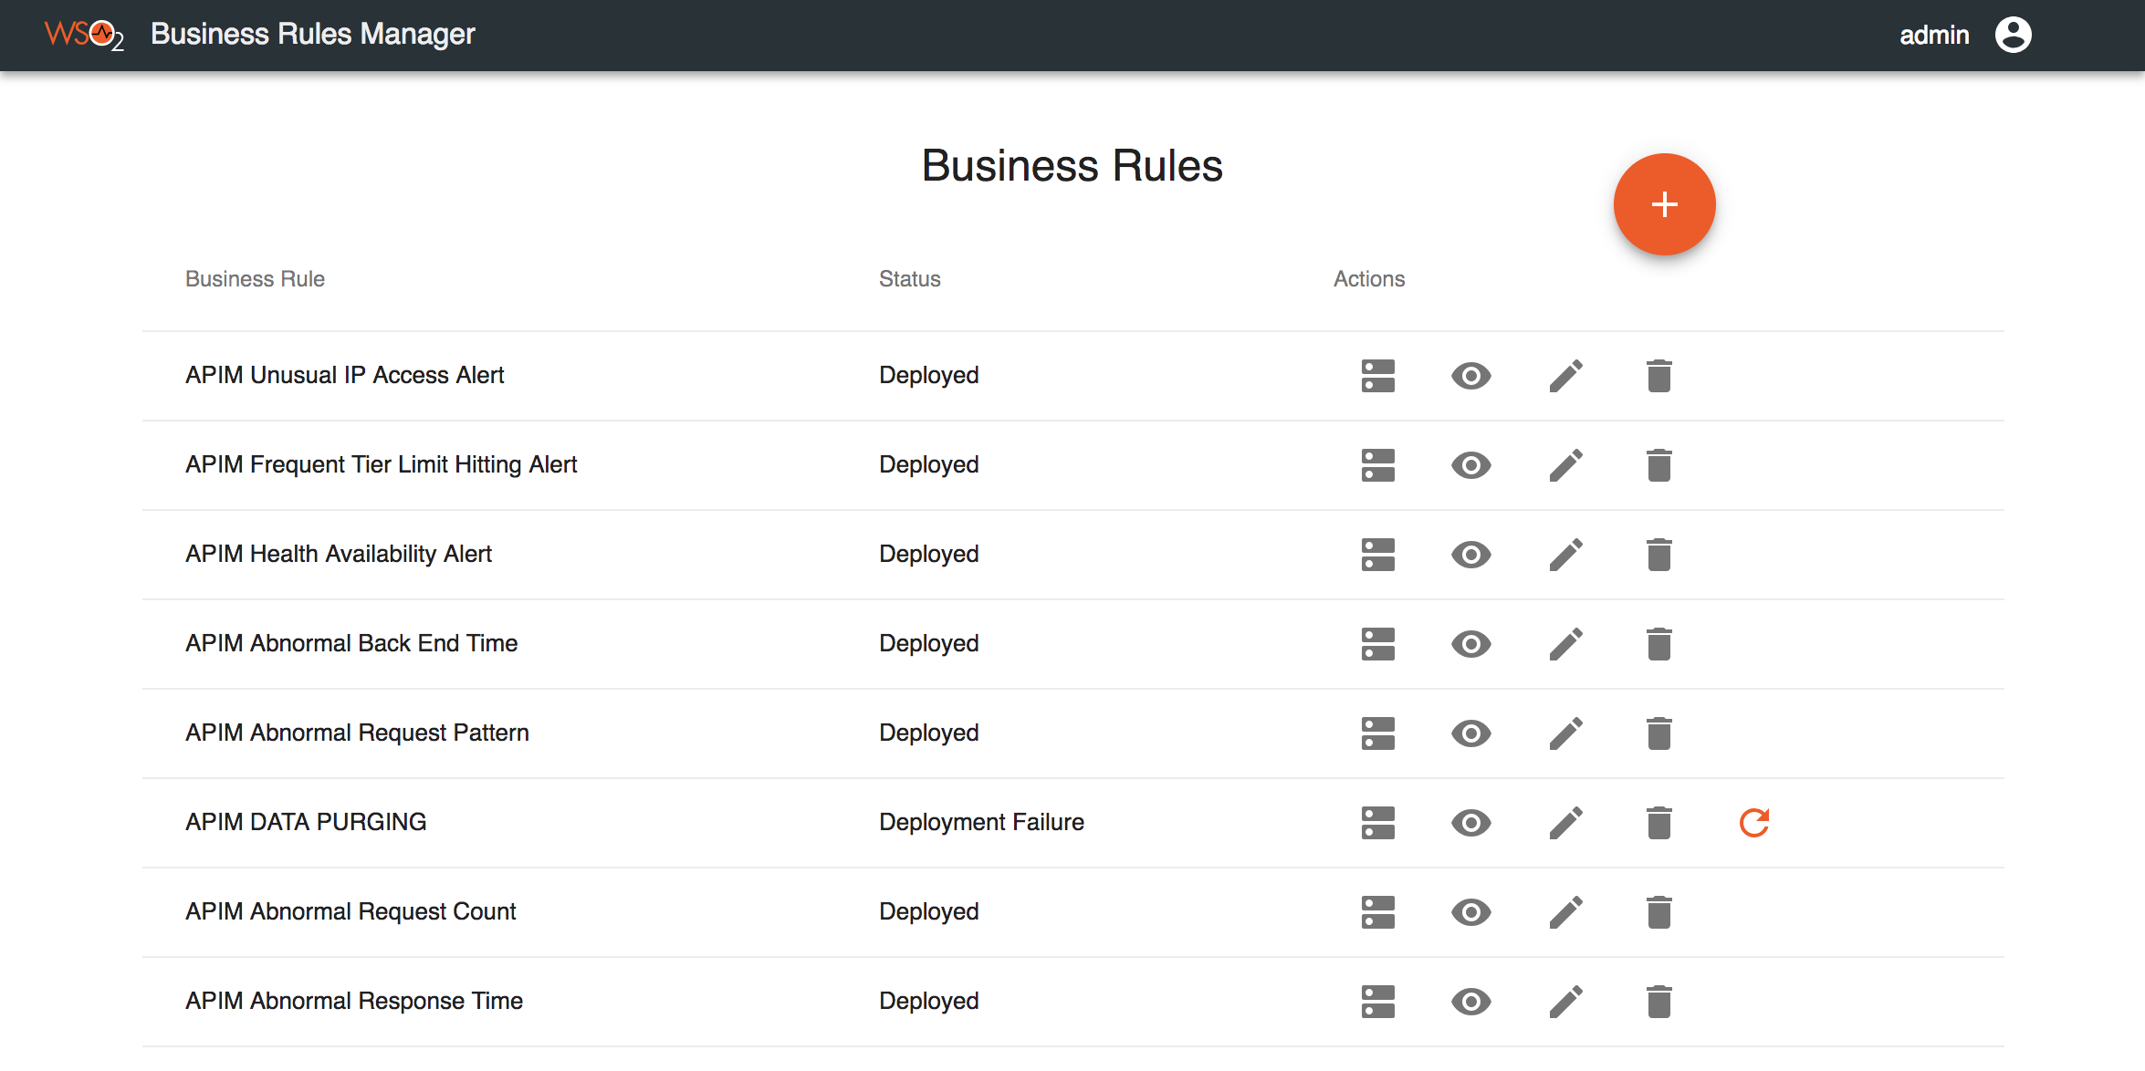
3. To edit parameters related to the frequent tier limit hitting alert click **Edit** in the **FrequentTierLimitHitting** section.

Expected Outcome

As a result of this exercise, Throttled out events are generated based on the API invocations and once the pre-defined tier crossing limit is exceeded, an alert is generated.